Final Part 3

Name：Tianyu Wei

URL: https://github.com/Jeffreylsq/Big-Data-part1.git

Implementation Kafka

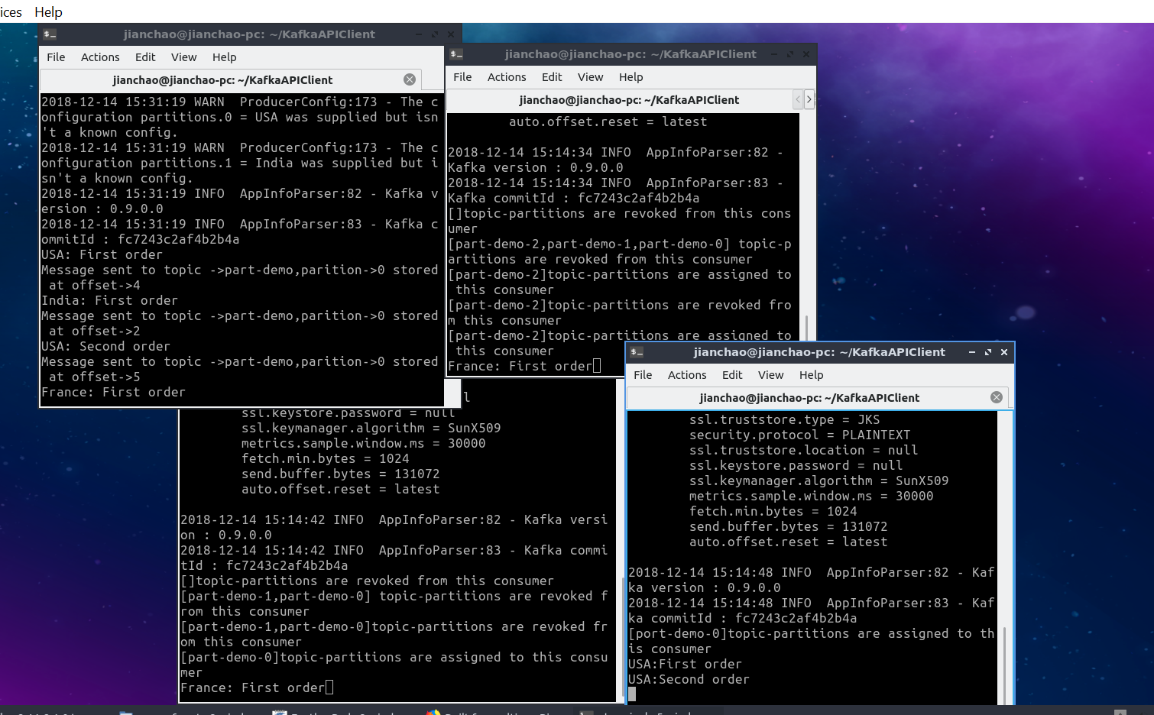

This is the result of Kafka part 2